**Experiment 1:**

**Aim:**

Introduction to Computer hardware: Physical identification of major components of a computer

system such as motherboard, RAM modules, daughter cards, bus slots, SMPS, internal storage

devices, interfacing ports.

**Course Outcome(CO2):**

**Procedure:**

1. A motherboard is the main circuit board inside a computer that connects all of the computer&#39;s

hardware components together, such as the central processing unit (CPU), memory, storage drives,

and expansion cards. It serves as a communication hub between these components, allowing them to

work together and perform various functions. The motherboard typically includes several important

components, including the chipset and the BIOS (Basic Input/Output System). Modern

motherboards come in different form factors, such as ATX, microATX, and mini-ITX, which

determine their size and layout. Overall, the motherboard is a critical component that plays a central

role in the operation of a computer.

2. RAM (Random Access Memory) modules are computer components that store data and

instructions temporarily while the computer is running. RAM is a type of volatile memory, which

means that its contents are erased when the computer is turned off or restarted. RAM modules come

in various types, speeds, and capacities. They are typically installed in slots on the motherboard and

can be easily upgraded or replaced. RAM modules are also used to support multitasking, where

multiple programs can run simultaneously. RAM modules are an essential component of a computer

that provides temporary storage for data and instructions. They help to improve the computer&#39;s

performance and support multitasking.

3. A daughter card, also known as a daughterboard or expansion card, is a circuit board that connects

to the main motherboard of a computer to add new functionality or enhance existing features.

Daughter cards are commonly used to expand the capabilities of a computer, such as adding

additional ports, memory, or processing power. Examples of daughter cards include graphics cards,

sound cards, network interface cards (NICs), and storage expansion cards.

4. A bus slot, also known as an expansion slot, is a socket on the motherboard of a computer that

allows expansion cards to be inserted and connected to the computer&#39;s bus system. There are several

types of bus slots commonly used in computers, including Peripheral Component Interconnect

(PCI), PCI Express (PCIe), and Accelerated Graphics Port (AGP) slots. These slots vary in their

bandwidth, power, and physical size, and are designed to accommodate different types of expansion

cards. Expansion cards, such as graphics cards, sound cards, and network interface cards, are

connected to the computer&#39;s bus system through the bus slot, allowing them to communicate with

other components and exchange data

5. SMPS stands for Switched-Mode Power Supply, and it is a type of power supply used in

computers and other electronic devices. The SMPS is responsible for converting AC power from a

wall outlet into DC power that the computer can use to operate. SMPS uses high frequency

switching and regulation to convert AC power to DC power more efficiently. SMPS units are

widely used in modern computers, as they are more reliable, energy efficient, and generate less heat

than linear power supplies. SMPS is an essential component of modern computers that plays a vital

role in powering the system and ensuring its proper operation.

6. Internal storage devices are electronic components used to store data within a computer or other

electronic devices. There are two main types of internal storage devices: Hard Disk Drives (HDDs)

and Solid State Drives (SSDs). HDDs are the traditional type of internal storage device and are

typically larger in capacity than SSDs. They consist of spinning disks that store data magnetically

and read/write heads that move over the disks to access the data. SSDs, on the other hand, use flash

memory to store data and have no moving parts, which makes them faster, more durable, and more

energy-efficient than HDDs. They are typically more expensive than HDDs.

7. Interfacing ports refers to the process of connecting different devices or components together in

order to exchange information or perform certain tasks. Ports are used to facilitate communication

between devices, and they can come in different forms, such as USB ports, Ethernet ports, HDMI

ports, and so on. Interfacing ports is an important aspect of modern computing, as it allows us to

connect a wide range of devices and components together in order to create complex systems and

networks. Whether it&#39;s connecting a keyboard and mouse to a computer, or setting up a network of

servers and workstations in a large enterprise, interfacing ports is a crucial part of the process.

**Result:**

Output displayed successfully and CO2 was obtained.

**Experiment No.: 3 Date: 07-03-2023**

**Aim :** Familiarisation of Linux Commands.

**CO 2:** Perform System Administration task.

**Procedure:**

pwd (Print Working Directory)

To find out the path of the current working directory (folder) you are in.

**Output Screenshot**



history

To review the commands you have entered before. Command number to run a command from history.

**Output Screenshot**

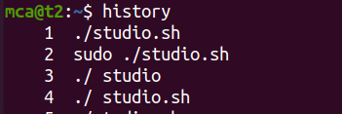

ls

The ls command is used to view the contents of a directory. By default, this command will display the contents of your current working directory.

**Output Screenshot**



*ls -a

This will show the hidden files



**Output Screenshot** 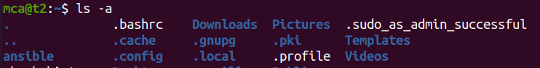

*ls -R

This will list all the files in the sub-directories as well

**Output Screenshot**

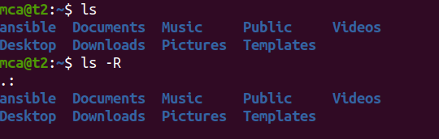

*ls –l (Long listing)

This command displays the contents of the current directory in a long listing format, one per line

**Output Screenshot**

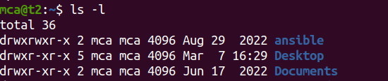

*ls -al

It will list the files and directories with detailed information like the permissions, size, owner, etc.

**Output Screenshot** 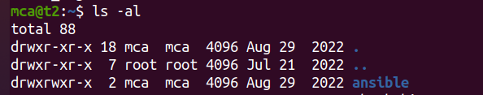

*ls -t

It will lists files sorted in the order of “last modified”.

**Output Screenshot**

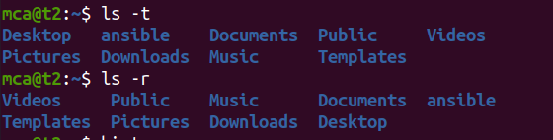

*ls -r

It will reverse the natural sorting order. Usually used in combination with other switches such as ls -tr. This will reverse the time-wise listing.

**Output Screenshot**



touch

The touch command allows you to create a blank new file through the Linux command line.

**Output Screenshot**

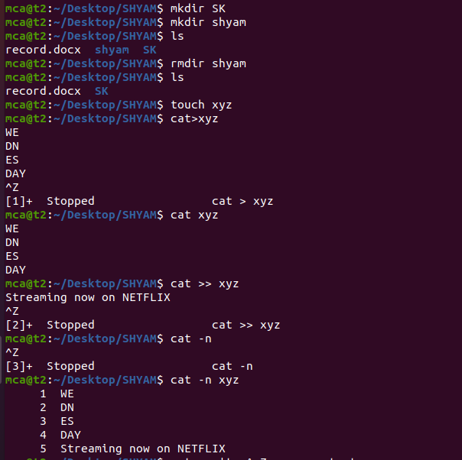

mkdir

Use mkdir command to make a new directory. Use the p (parents) option to create a directory in between two existing directories.

**Output Screenshot**



cp file1 file2

This command is used to copy files from the current directory to a different directory.

**Output Screenshot**

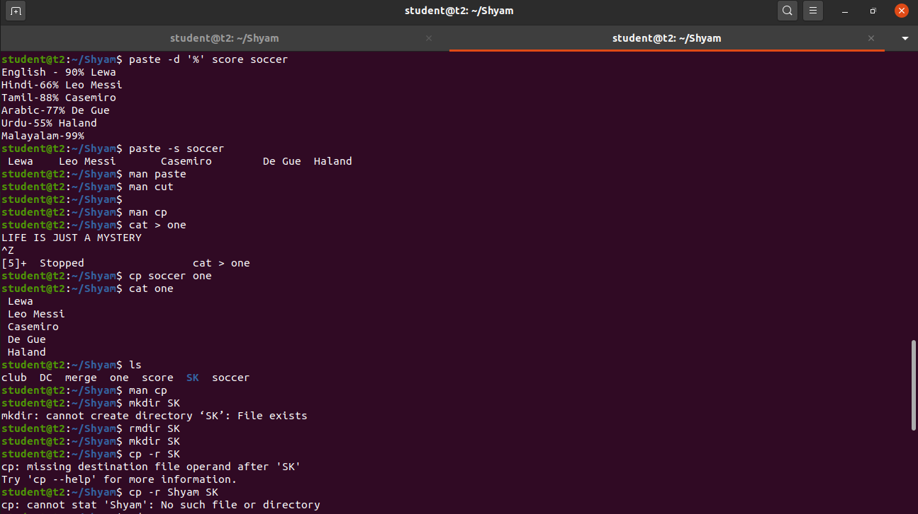

Cat >

To create a file.

**Output Screenshot**

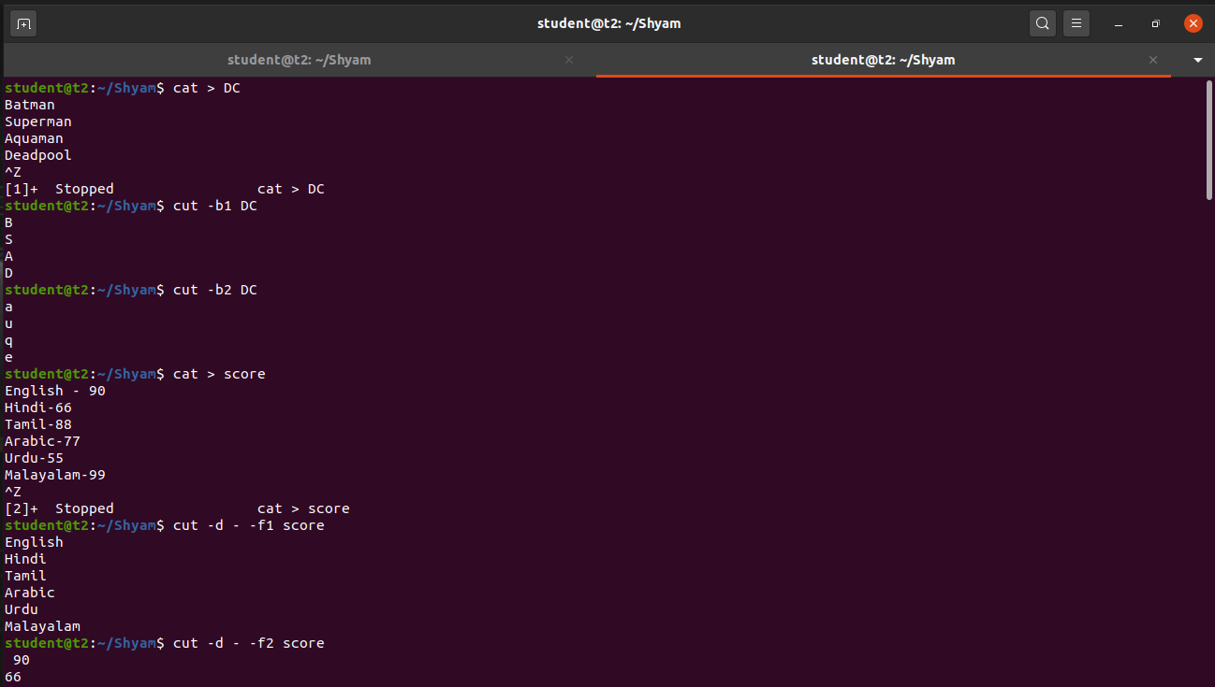

cat>>

This command will append (add something in the last of a file) something in your already existing file.

**Output Screenshot**

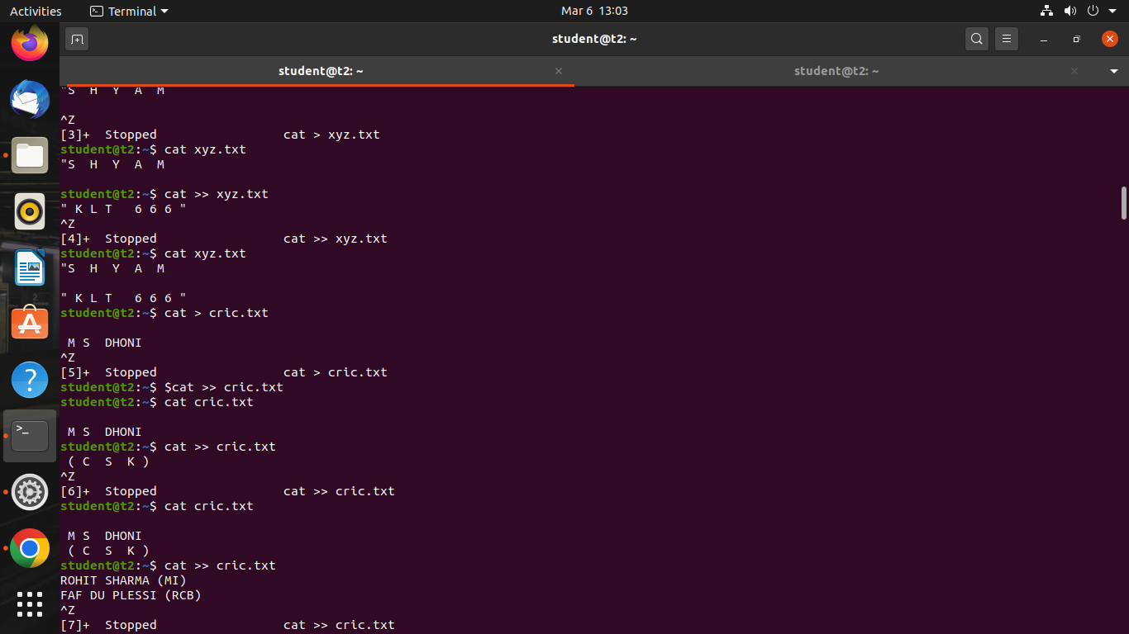

cat filename

This command will displays the contents of a file in the terminal.

**Output Screenshot**



cat -n

This command will display the contents of a file in the terminal, with line numbers displayed before each line.

**Output Screenshot**



cat a b

This command displays the contents of both files in the terminal, with the contents of file "a" displayed first, followed by the contents of file "b".

**Output Screenshot**

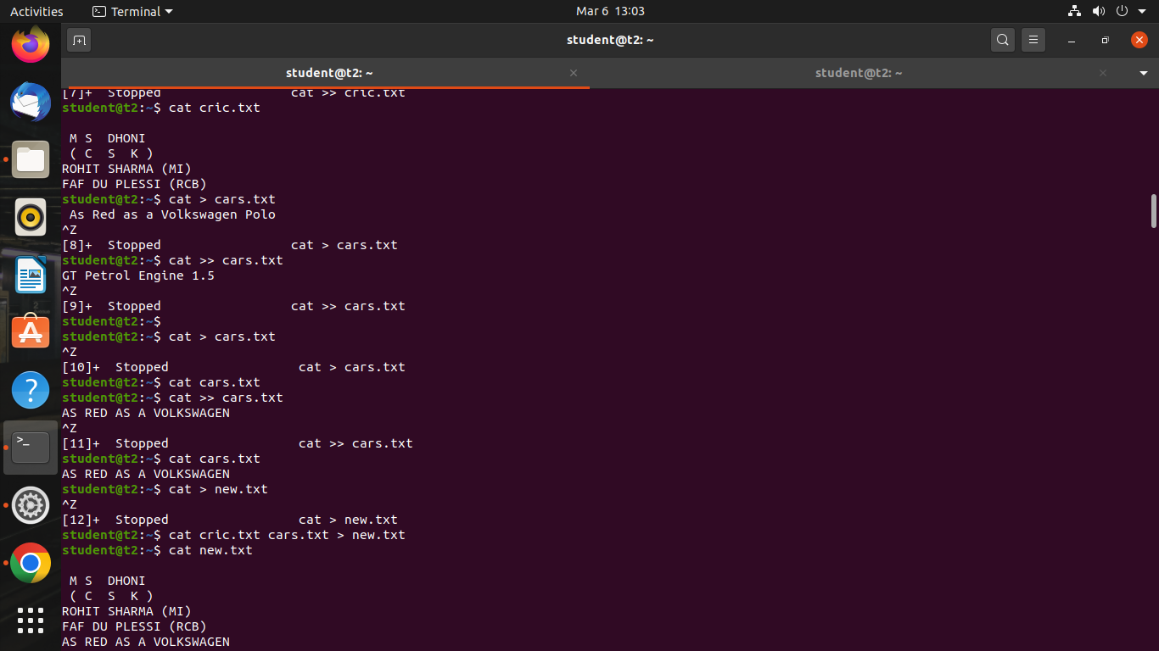

cat -E filename.txt – Display $ at end of each line

**Output Screenshot**

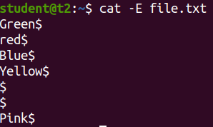

cd

This command is used to change the current working directory to a specified directory.

**Output Screenshot**

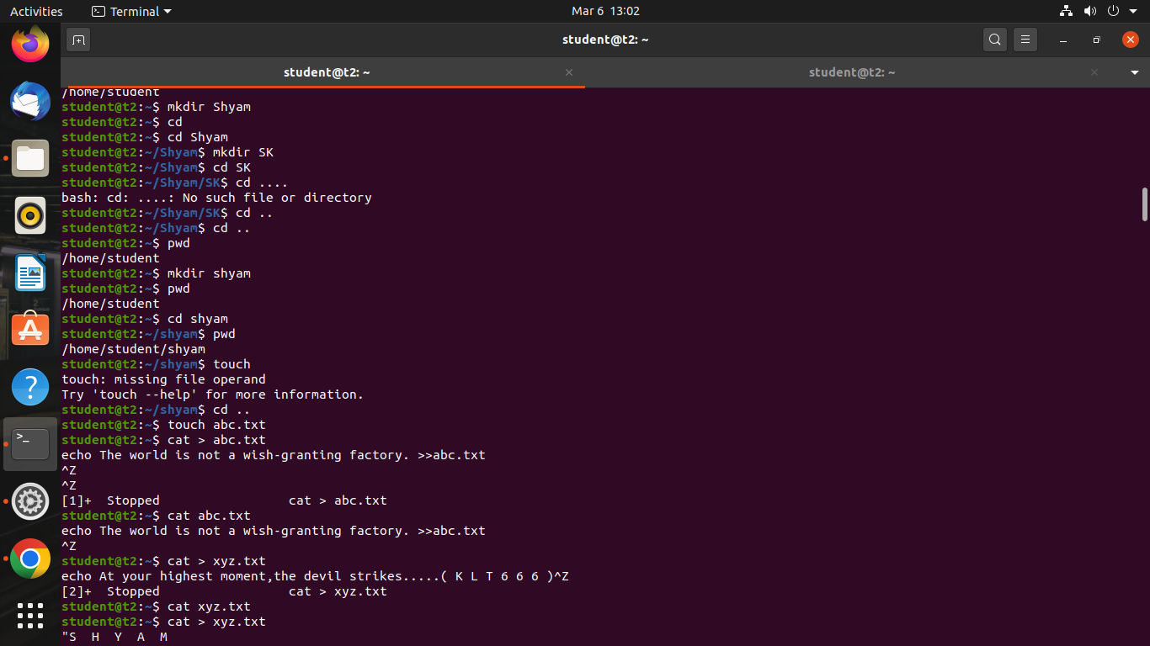

cd ..

This command is used to change the current working directory to the previous directory.

**Output Screenshot**



**Result**

The program was executed and the result was successfully obtained. Thus CO2 was obtained.

**Experiment No.: 4 Date: 07-03-2023**

**Aim :** Familiarisation of Linux Commands.

**CO 2:** Perform System Administration task.

**Procedure:**

cut -b1

This command is used to extract the first byte or character of each line from a file or output, where "b" stands for "byte" and "1" refers to the first byte or character position.

**Output Screenshot**



cut -b2

**Output Screenshot**



cut –c 1,2,3

This command is used to extract the characters or column of each line from a file or output, where "c" stands for "character" and "1,2,3" refers to the column positions.

**Output Screenshot**

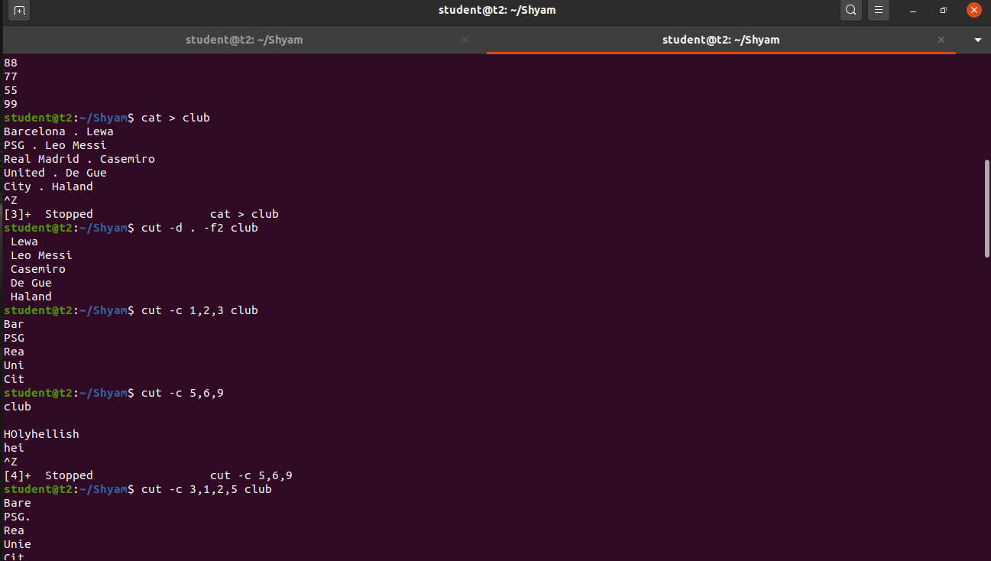

man

The command "man" is used to learn and understand about different commands right from the shell.

**Output Screenshot**



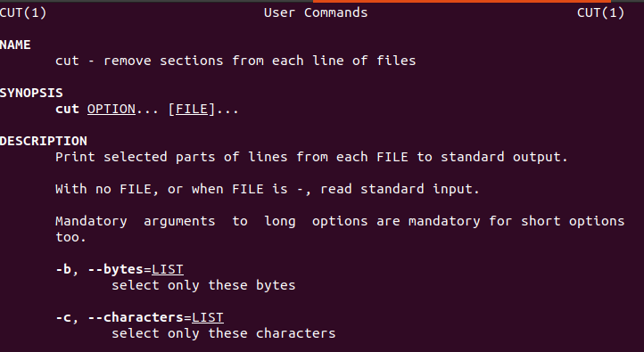

rmdir

The "rmdir" command is used to remove or delete an empty directory in a file system from the command line or terminal

**Output Screenshot**.



tr a-z

To convert the content into lower case letters

**Output Screenshot**

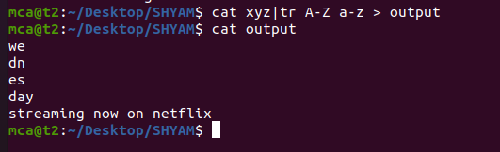

paste – The command is used to join files horizontally

**Output Screenshot**

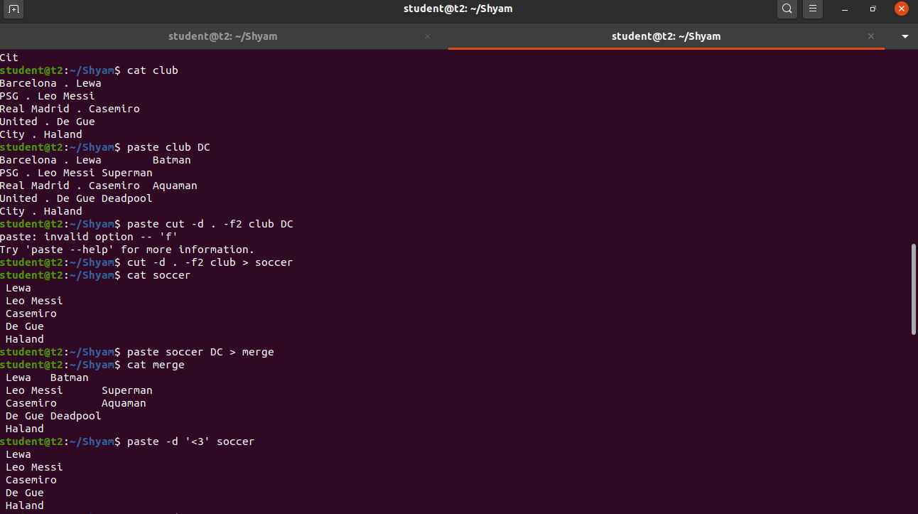

**Result**

The program was executed and the result was successfully obtained. Thus CO2 was obtained.

**Experiment No.: 5 Date: 13-03-2023**

**Aim :** Familiarisation of Linux Commands.

**CO 2:** Perform System Administration task.

**Procedure:**

1. read : read a line

$read

$ echo $REPLY

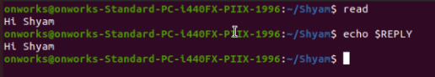

1.1. Read into variables

$ read var1 var2

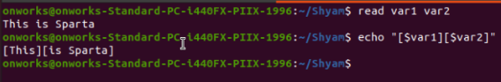

1.2 read multiple lines using backslash

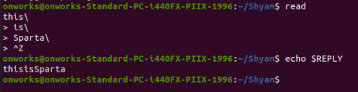

1.3 $read -p : Prompt something in the screen

$read -p “something ”

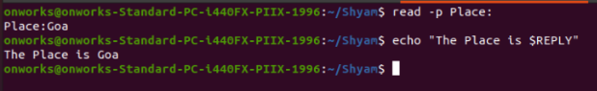

1.4 $read - n: read only a specific length of characters



1.5 $read -s : read secure data like passwords

$read -s -p “Enter password”

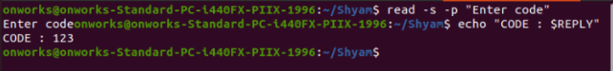

2. $wc filename: display the details of file

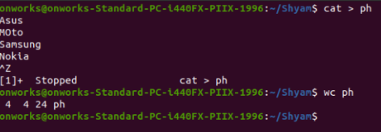

2.1 $wc -l : To display number of lines

$wc -l profile

2.2 $wc -m : To display number of bytes

$wc -m profile

2.3 $wc -c : To display number of characters

$wc -c profile

2.4 $wc -w: To display number of words

$wc -w profile

2.5 $wc -L : Length of the longest line

$wc -l profile

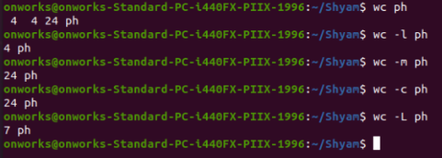

2.6 $more : command is used to view the text files in the command prompt, displaying

one screen at a time in case the file is large

$more myfile.txt

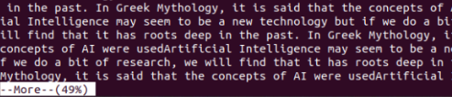

2.7 $more +/something : Search the pattern string

$more +/Deep myfile.txt



2.8 $more -d:help user to navigate , press space to continue, q to quit

$more -d myfile.txt

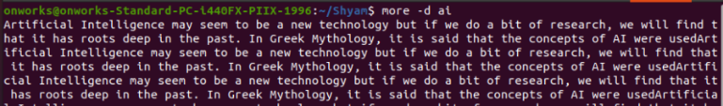

**Result**

The program was executed and the result was successfully obtained. Thus CO2 was obtained

**Experiment No.: 6 Date: 14-03-2023**

**Aim :** Familiarisation of Linux Commands.

**CO 2:** Perform System Administration task.

**Procedure:**

1. **Grep** - filter searches a file for a particular pattern of characters, and displays all lines that contain that pattern.

$grep amal hello.txt Output:

https://lh3.googleusercontent.com/oq3eCHUOW65F-Lfg_NqUC9coufjcne581oxEJPlo-n7FISpzofcoDzLlqWjEBAl5CzBurG3I-FCx5FciPVhA7dqcXpTccheuby0k7TWeAjtZNXwXgcoj_ic7toy1hjt1z4DIQnVL1_arqqzS2bOzQ-g

1. Grep -i -To perform case insensitive search

$grep -i Fluter file1 Output:

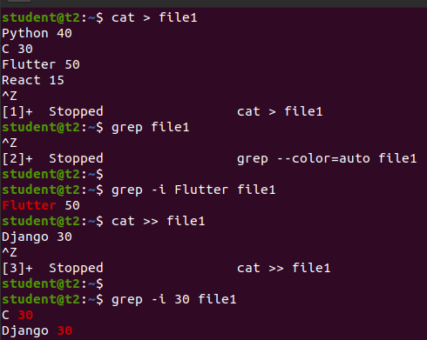

1. Grep -A1- To view the content searched along with one line after

$grep -A1 Fluter file1

Output:

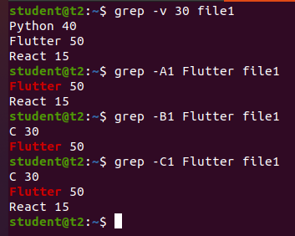

1. Grep -B1 -To view the content searched along with one line Before

$grep -B1 Fluter file1

Output:



1. Grep -C1 -To view the content searched along with one line after & Before

$grep -C1 Fluter file1

Output:



1. Head - To display the first lines of files . By default, it shows the first 10 lines

$head car

Output:

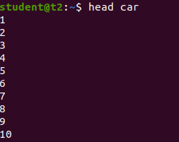

1. Head -number -To display the first n number of lines of files

$head -3 car

Output:

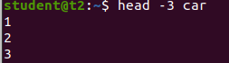

1. Tail -To display the last lines of files . By default, it shows the first 10 lines

$tail car Output:

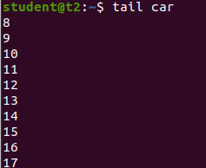

1. Tail -n - To display last n number of lines of files

$tail -3 car.txt Output:

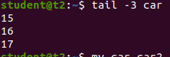

1. Mv -**mv** stands for move. **mv** is used to move one or more files or directories from one place to another

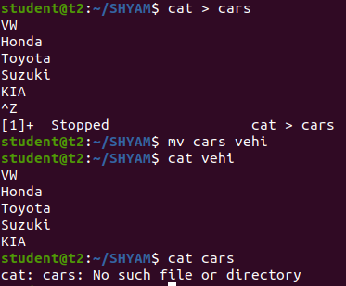

1. Mv -b -to create backup while moving file

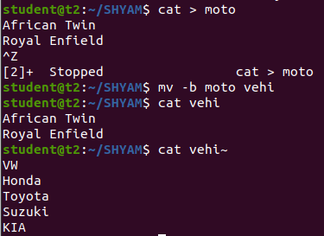

1. Mv i -to display the prompt Warning message

$mv - i ipl ipl2

Output:

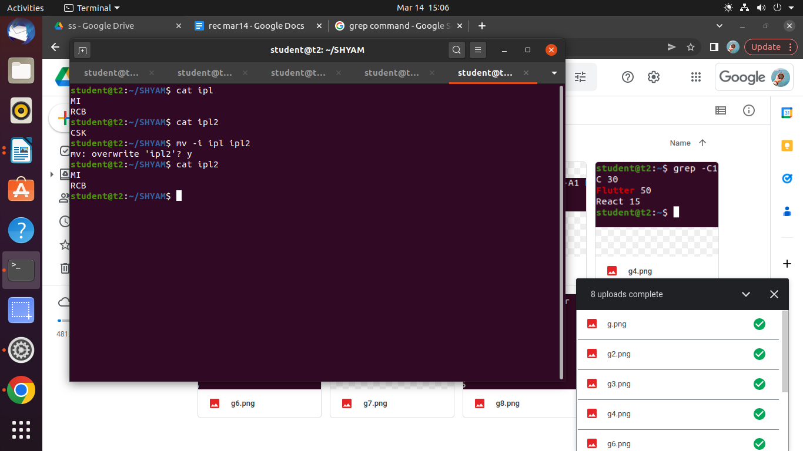

**Result**

The program was executed and the result was successfully obtained. Thus CO2 was obtained.

**Experiment No.: 7 Date: 20-03-2023**

**Aim :** Familiarisation of Linux Commands.

**CO 2:** Perform System Administration task.

**Procedure:**

1. Expr : Evaluate the given expression and display the result

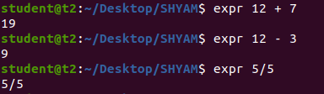

2. df : Get a report on system disk space usage

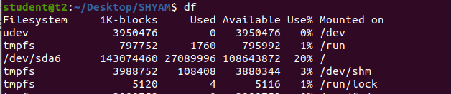

3. du : used to checks how much space a file or dir takes in the current directory

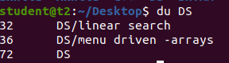

4. Create new user

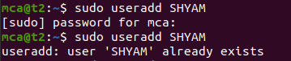

5.Change password of new user

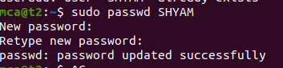

6. Group Add

sudo groupadd -g identifier - The groupadd command creates a new group account



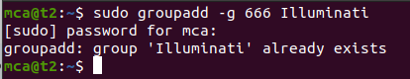

7 Sudo usermod -G : Add user to group

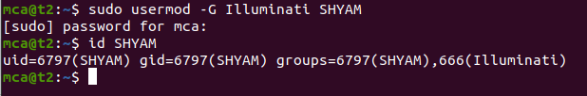

8. Compgen - To display all the groups

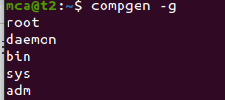

chmod : used to change the access permission of the file and directories.

It stands for change mod

Read – r

Write – w

Execute – x

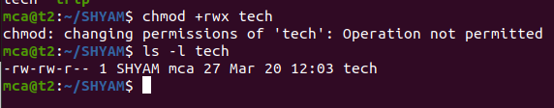

- (deny permissions)



+(allow permissions)

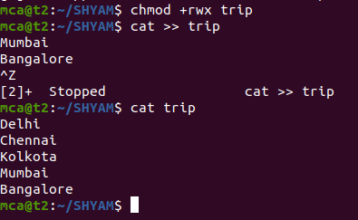

Chown : Used to change the file ownership or directory ownership for a user or group

And chown stands for change owner

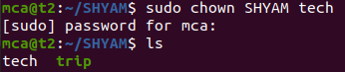

Delete user

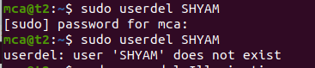

Delete group

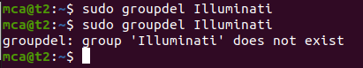

**Result**

The program was executed and the result was successfully obtained. Thus CO2 was obtained.

**Experiment No.: 8 Date: 21-03-2023**

**Aim :** Familiarisation of Linux Commands.

**CO 2:** Perform System Administration task.

**Procedure:**

$ip addr - to view the protocol address on a device.

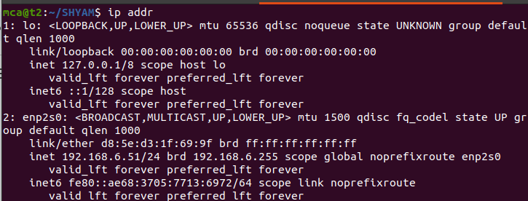

$ssh [user]@[ipaddress] - secure shell



sudo apt-get update

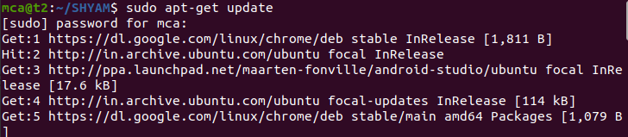

$ sudo apt-get install openssh-server

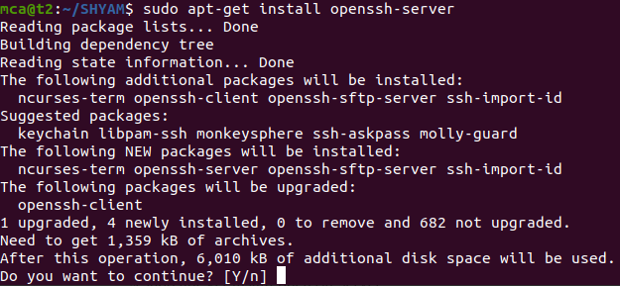

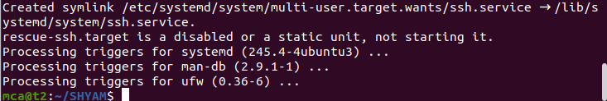

$sudo ufw allow 22

$ssh mca@[remote ip] - to connect with a remote host

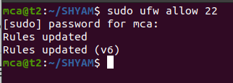

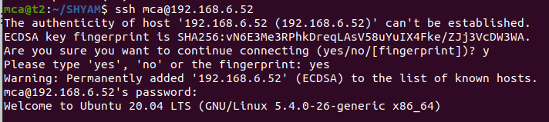

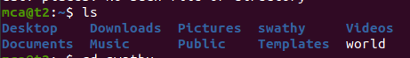

$ssh-keygen - to generate key

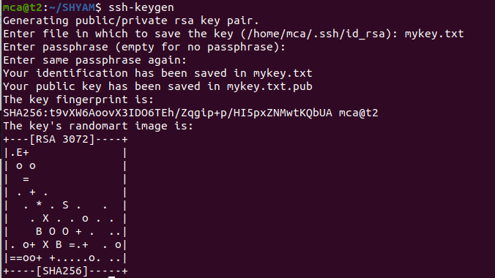

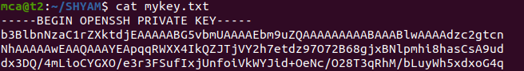

ps - report a snapshot of the current processes.

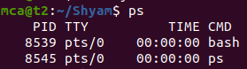

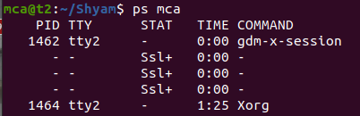

$ps -u [user] - to get info about current running applications.

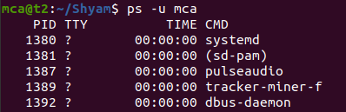

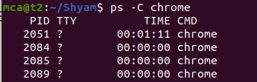

$ ps -f -p -

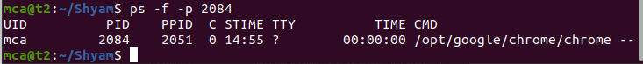

**Result**

The program was executed and the result was successfully obtained. Thus CO2 was obtained.

**Experiment No.: 9 Date: 21-03-2023**

**Aim :** Familiarisation of Linux Commands.

**CO 2:** Perform System Administration task.

**Procedure:**

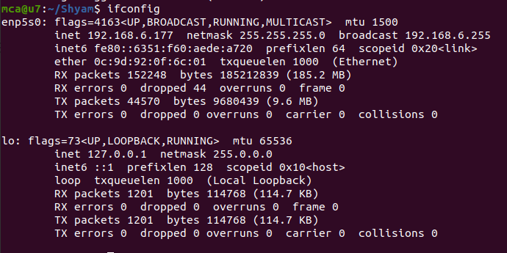

Mtu - maximum transfer unit

Ip address line 3

Mac address line 4

* Ifconfig  is  used to configure the kernel-resident network interfaces.It is used at boot time to set up interfaces as necessary.  After that, it  is  usually  only  needed  when  debugging or when system tuning is needed.

* The ifdown command disables a network interface, placing it in a state where it cannot transmit or receive data.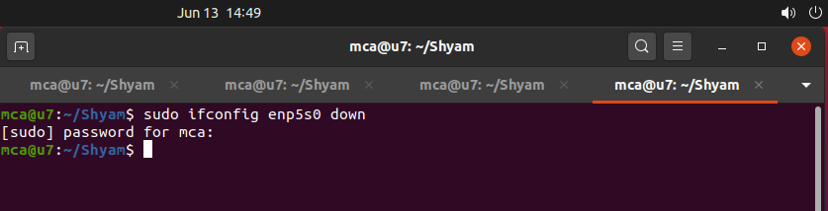

* ifup activates a network interface, making it available to transmit and receive data.

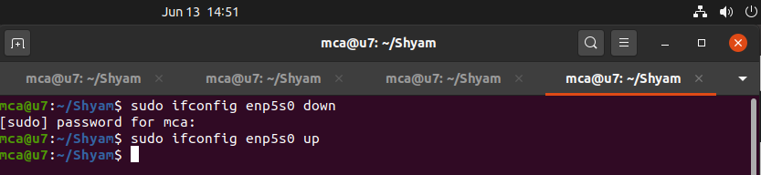

* PING (Packet Internet Groper) command is used to check the network connectivity between host and server/host. It is used to detect devices on a network and for troubleshooting. Fast ping low latency means faster connection.

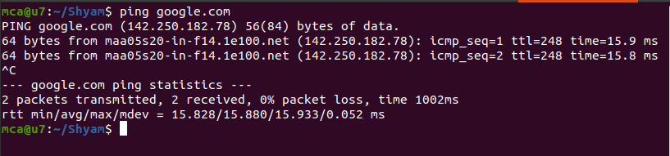

$ ping -c 3 google.com

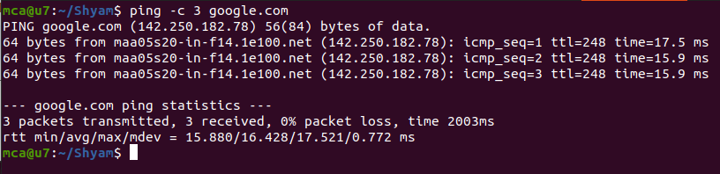

$ ping (ipaddress)

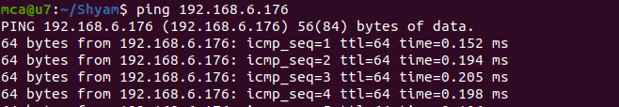

$ traceroute google.com

It is used to identify the route taken by the packets to reach the destination.

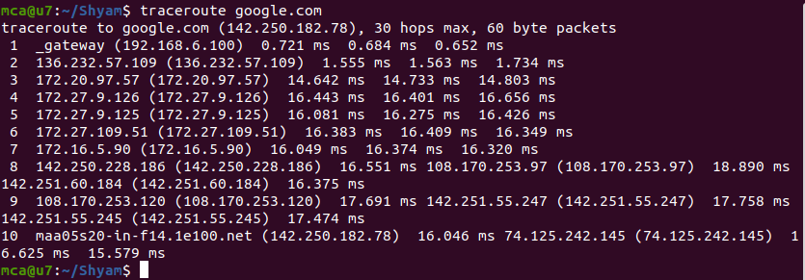

$ whois

The whois command displays all information about a specific domain.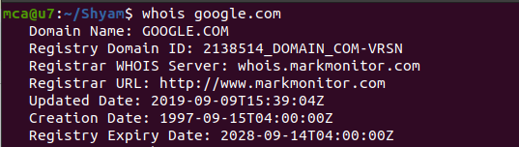

$ nslookup

The nslookup command is a tool used to query Domain Name System (DNS) servers and retrieve information about a specific domain or IP address.

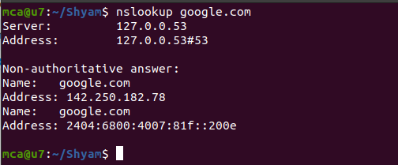

$wget

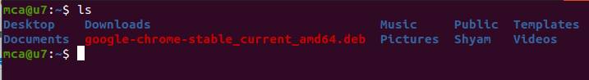

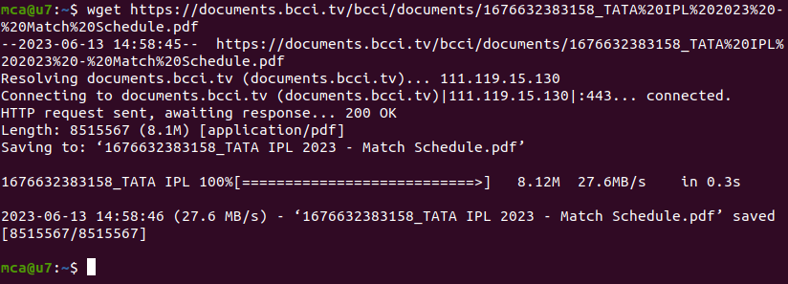

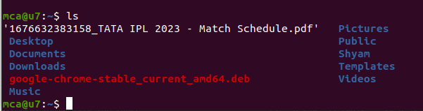

$ sudo tcpdump

It is used to capture the packets of current network interface.

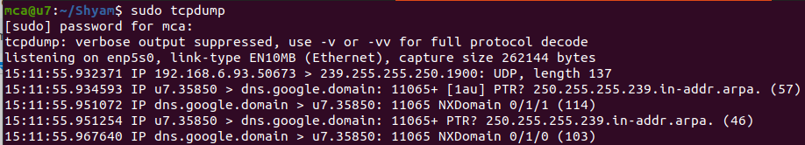

$ sudo tcpdump -D

It is used to capture packets from available interfaces.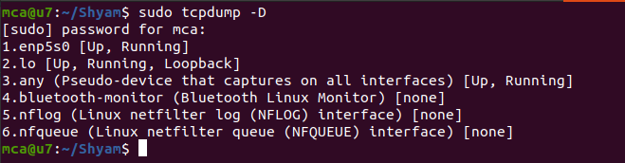

$ sudo tcpdump -i (interface)

It is used to capture packets from a particular interface.

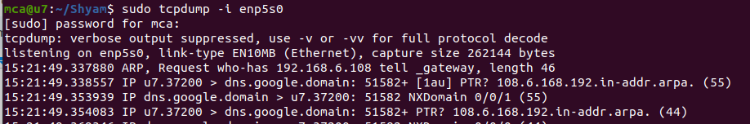

$ sudo tcpdump -c n -i enp5s0

It is used to capture n packets from a particular interface.

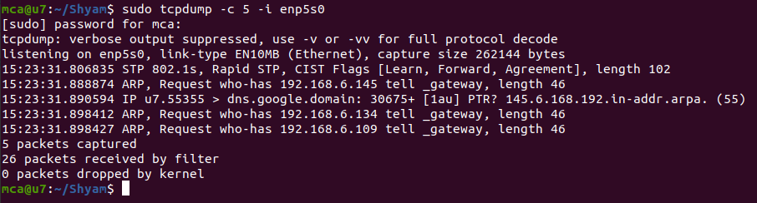

 $ sudo tcpdump -A -i interface

To display in ASCII format.

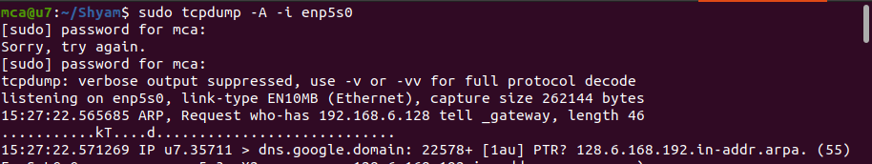

$ sudo tcpdump -XX -i interface

To display in Hexadecimal format

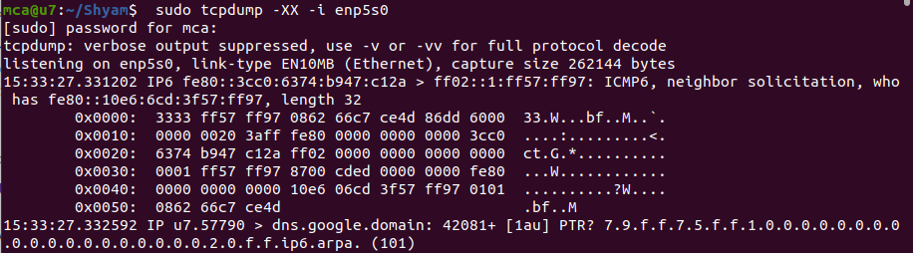

$ sudo tcpdump -w ab.pcap -i interface

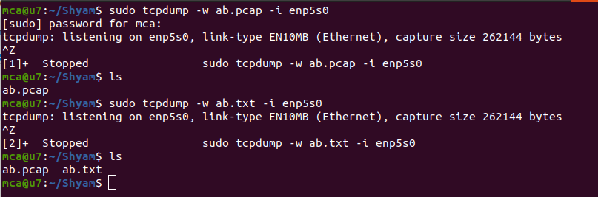

**Result**

The program was executed and the result was successfully obtained. Thus CO2 was obtained.

**Experiment No.: 10 Date: 21-03-2023**

**Aim :** Familiarisation of Linux Commands.

**CO 2:** Perform System Administration task.

**Procedure:**

FILE SYSTEM HIERARCHY

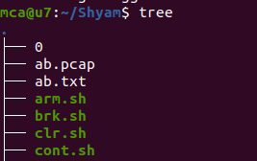

**/bin**

The '/bin' directory contains user binaries, executable files, Linux commands that are used in single user mode, and common commands that are used by all the users

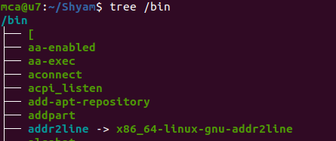

**/boot**

The /boot/ directory contains static files required to boot the system, such as the Linux kernel. These files are essential for the system to boot properly.

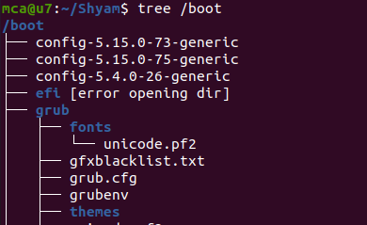

**/dev/**

The /dev/ directory contains device files representing the physical and virtual devices such as harddrives, printers, cpu etc..

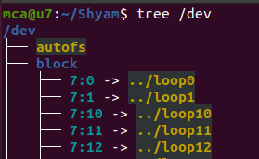

**/etc/**

The /etc/ directory is reserved for configuration files for various applications and services.

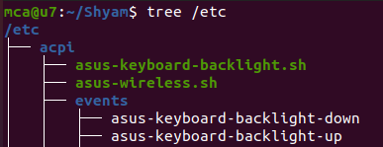

**/home**

It is the home directory for regular users.

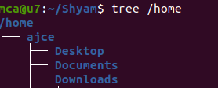

**/lib**

The /lib/ directory should contain only those libraries needed to execute the binaries in /bin/ and /sbin/.

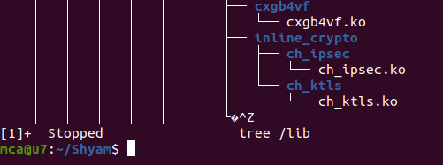

**/mnt**

 temporary file attachment systems , eg: External drives, network shares.

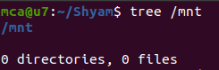

**/media**

 Temporary mount system for Removable media eg: usb , optical disk , external hard drives

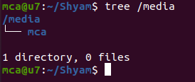

**/opt**

for storing optional packages

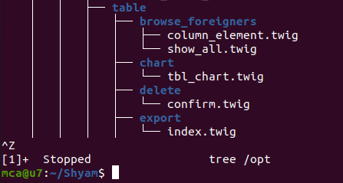

**sys**

Exposes informations about system hardware and devices

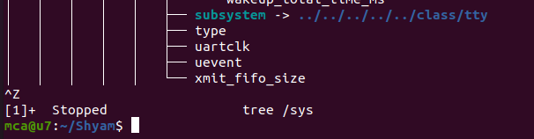

**/tmp**

Temporary files created by users and applications.

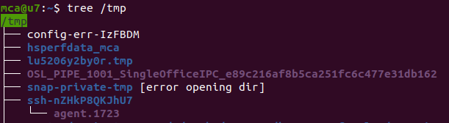

**/usr**

Contains user programs and libraries.

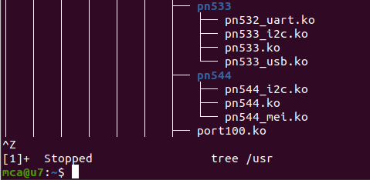

**/var**

Contains variable data that changes frequently such as lock files and cache files.

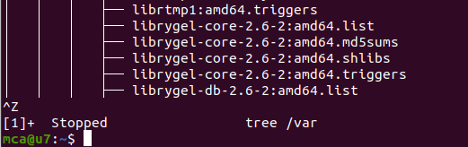

**Result**

The program was executed and the result was successfully obtained. Thus CO2 was obtained.